**DCRN Wallet IOS Installation and Stake Tutorial**

Step 1: Open TestFlight, search for DCRN Wallet and download and install it.

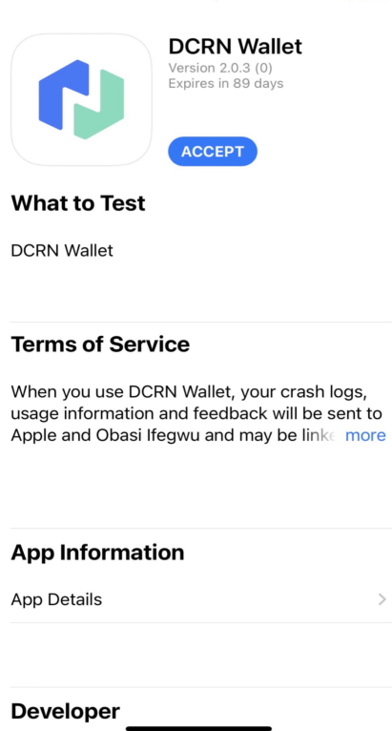

Step 2: Open the DCRN Wallet and click **Create a new wallet**

If you already have a DCRN Wallet (Seed phrase), you can click **Restore an existing wallet**

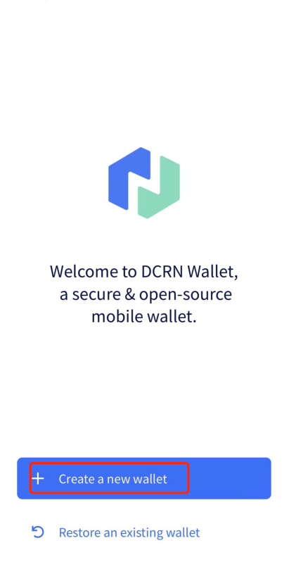

Step 3: Click **Create** after setting the password

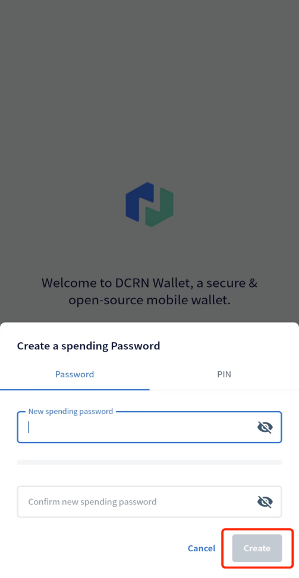

Step 4: Click **Go to Wallet**→**Back up seed words**, follow the steps to save and verify the seed words, then DCRN Wallet creation is complete.

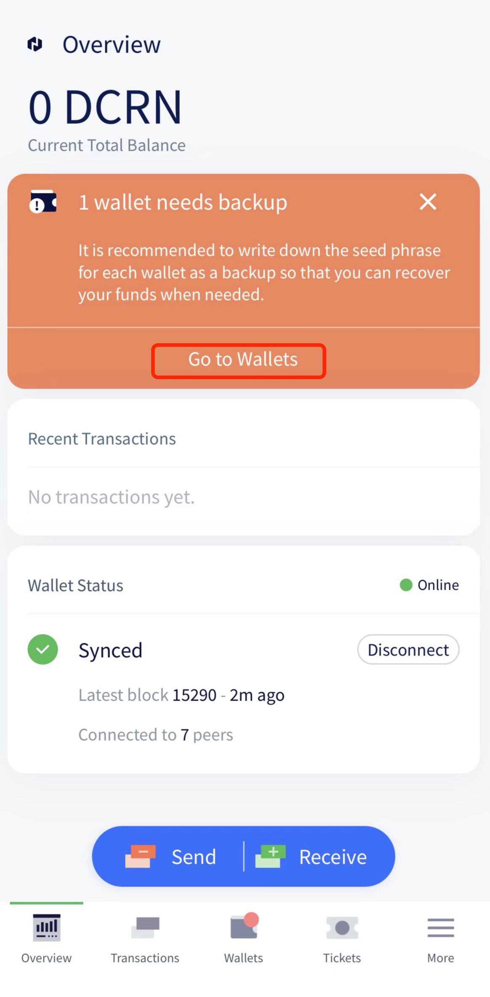

Step 5: Open the website: <https://dcrn.xyz/stake> , and click on **link**

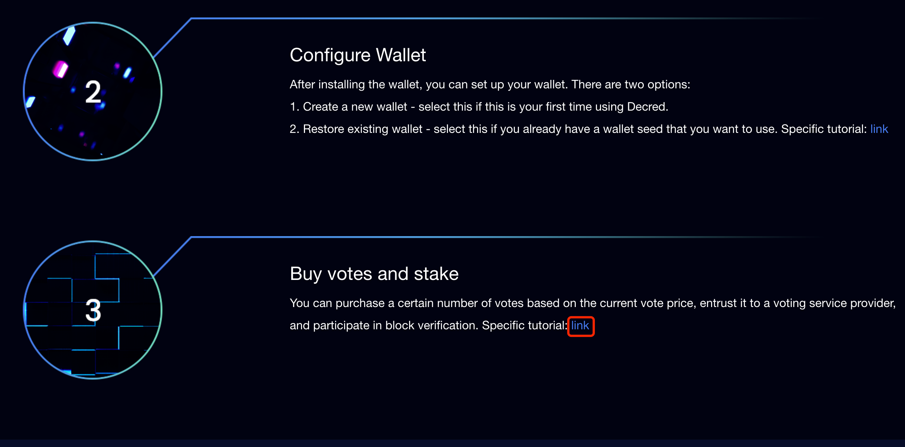

Step 6: Click VSP1 Address



Step 7: Click **Register** to register your account

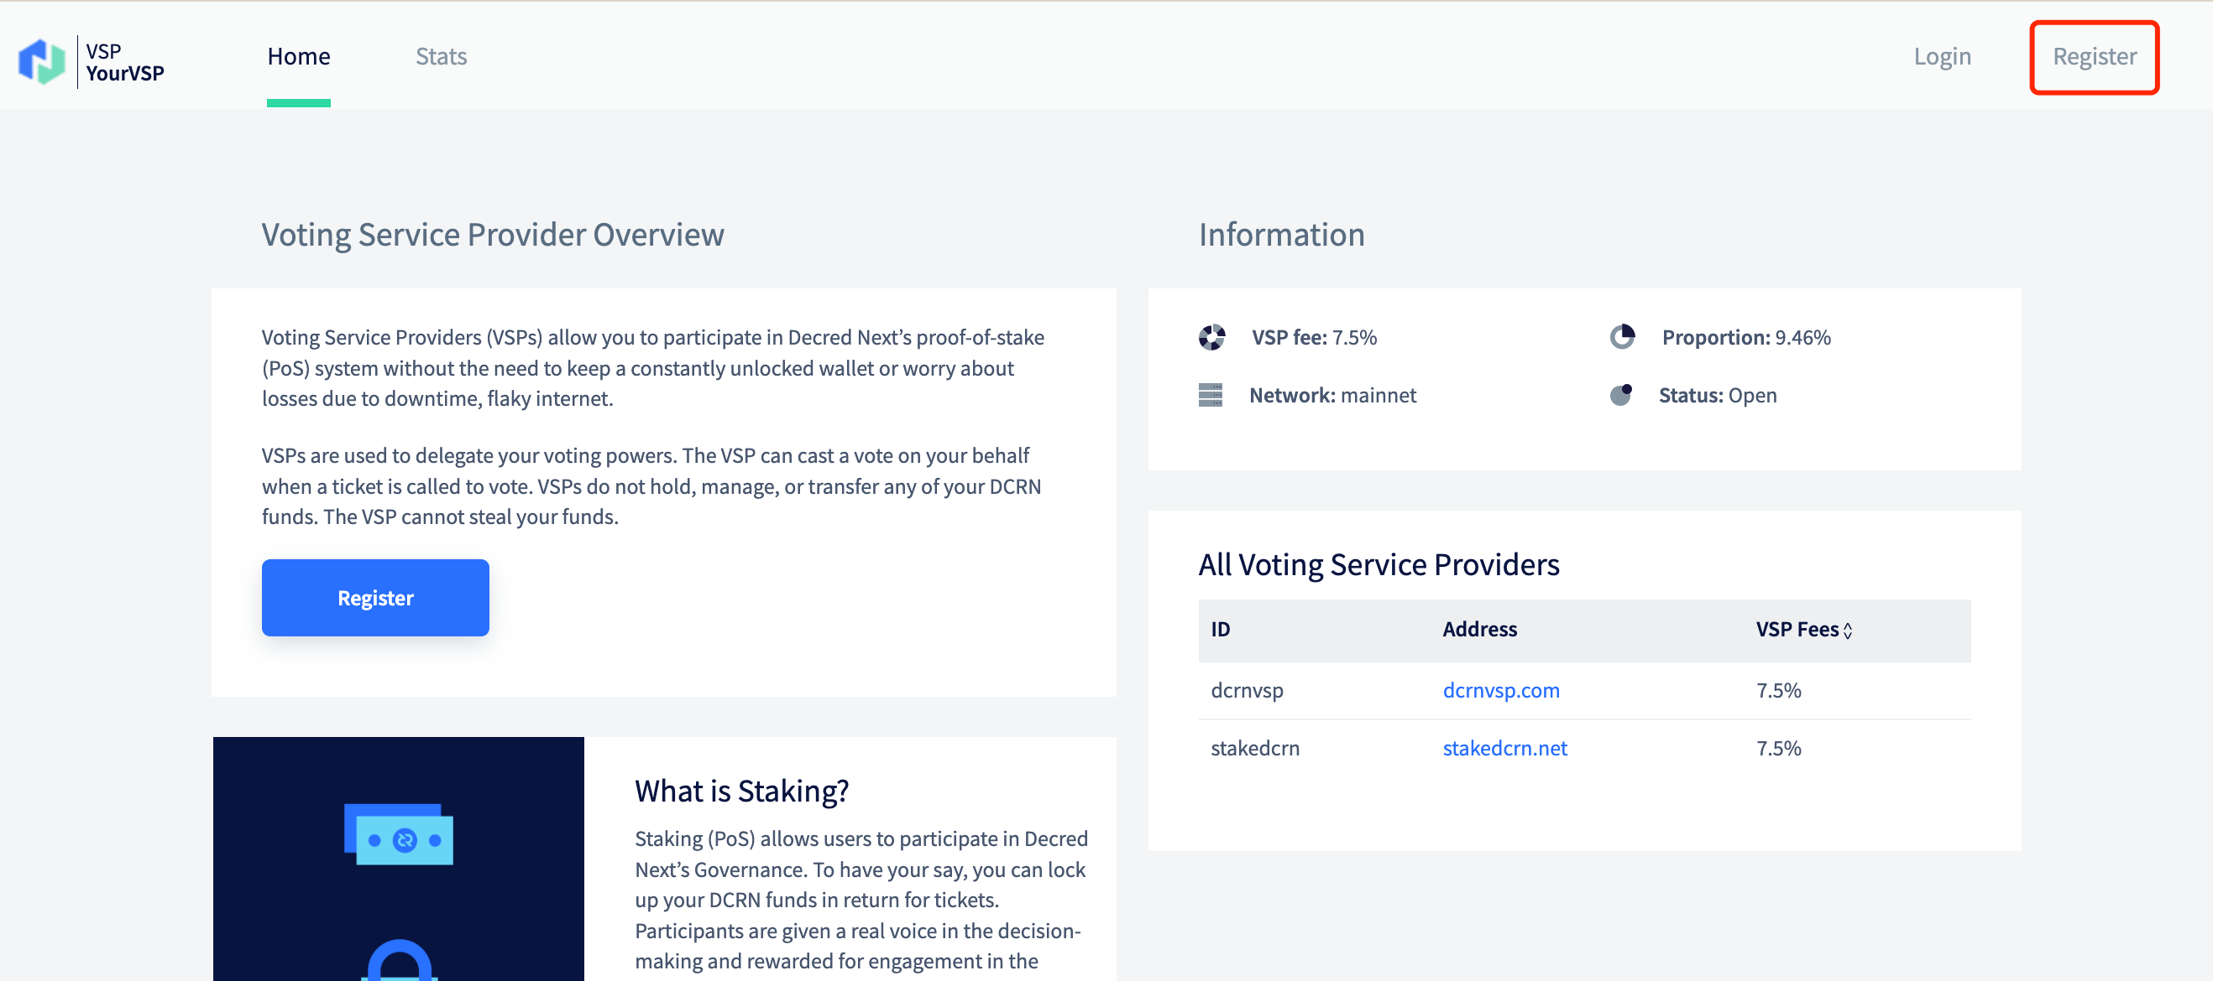

Step 8: Login after registration and click **Connect to Wallet** to get the **API KEY**

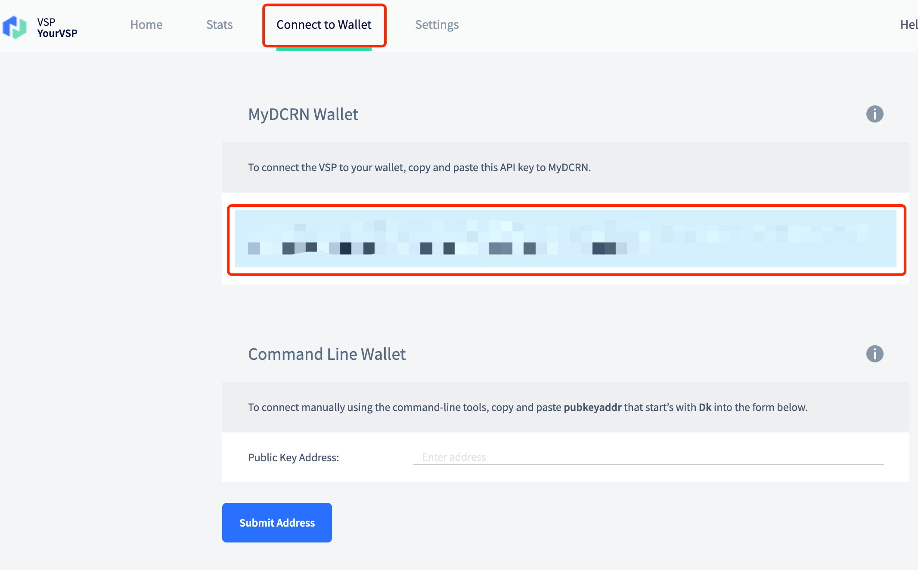

Step 9: Click on **Tickets**→**Add a VSP**

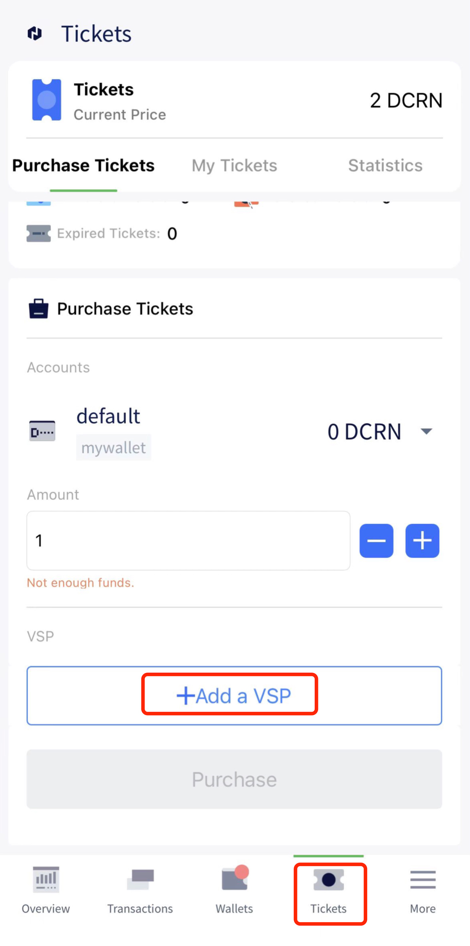

Step 10: VPS select **https://stakedcrn.net**, paste the obtained API KEY and click "Continue" to finish adding the VSP.

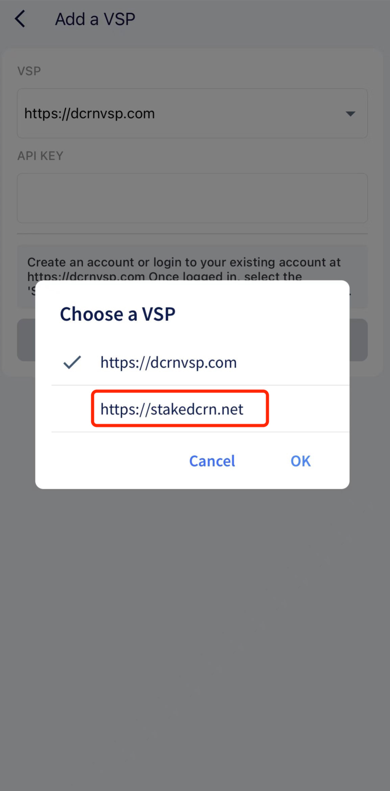

Step 11: You can purchase Tickets based on the DCRN balance to complete the Stake.

